Path Name | Method | Full URL (origin + path) | Auth Required? | One-line: what the server does
Control | GET | https://prin-of-software-methodology-project-m.onrender.com/health | No | Health check endpoint for uptime/status
Write | POST | https://prin-of-software-methodology-project-m.onrender.com/api/register | No | Register a new user account
Write | POST | https://prin-of-software-methodology-project-m.onrender.com/api/login | No | Log in and return bearer token
Write | POST | https://prin-of-software-methodology-project-m.onrender.com/api/messages | Yes | Create a post (write operation)
Read | GET | https://prin-of-software-methodology-project-m.onrender.com/api/messages | Yes | Read/list posts (read operation)

BASE_H = https://prin-of-software-methodology-project-m.onrender.com
BASE_L = http://127.0.0.1:8000
Git commit I am on: index.html update

first /health wall time (slow or fast): Slow.
After warmup, /health feels: Fast.

Call | http_code | Time_total (s) | Time_starttransfer (s) | Size_download (bytes)
GET /health | 200 | 0.319487 | 0.319311 | 15
Authenticated read path | 200 | 0.972848 | 0.972648 | 556
Authenticated write path | 405 | 0.290377 | 0.290191 | 31

payload of the read path ≈ 556 bytes.
login path: /api/login
JSON key for the token: eyJhbGciOiJIUzI1NiIs...
Token lifetime: 7 days.
size_download (bytes) =14362

status codes you actually got (health / read / write / patch):
health - 200
read – 200
write – 200
patch – 200
GET /api/messages probably hit Postgres hardest because the handler executes a multi-row SELECT and returns the full result set, while POST and PATCH touch only one row. Health is a very simple check and does not scale like the others.

Hosted
When | Laptop Clock | Dashboard TZ (if different) | CPU (approx. %) | Memory | Screenshot File
Idle (no curls for a minute) | 10:33 AM | Not Different | <1% | 18% | 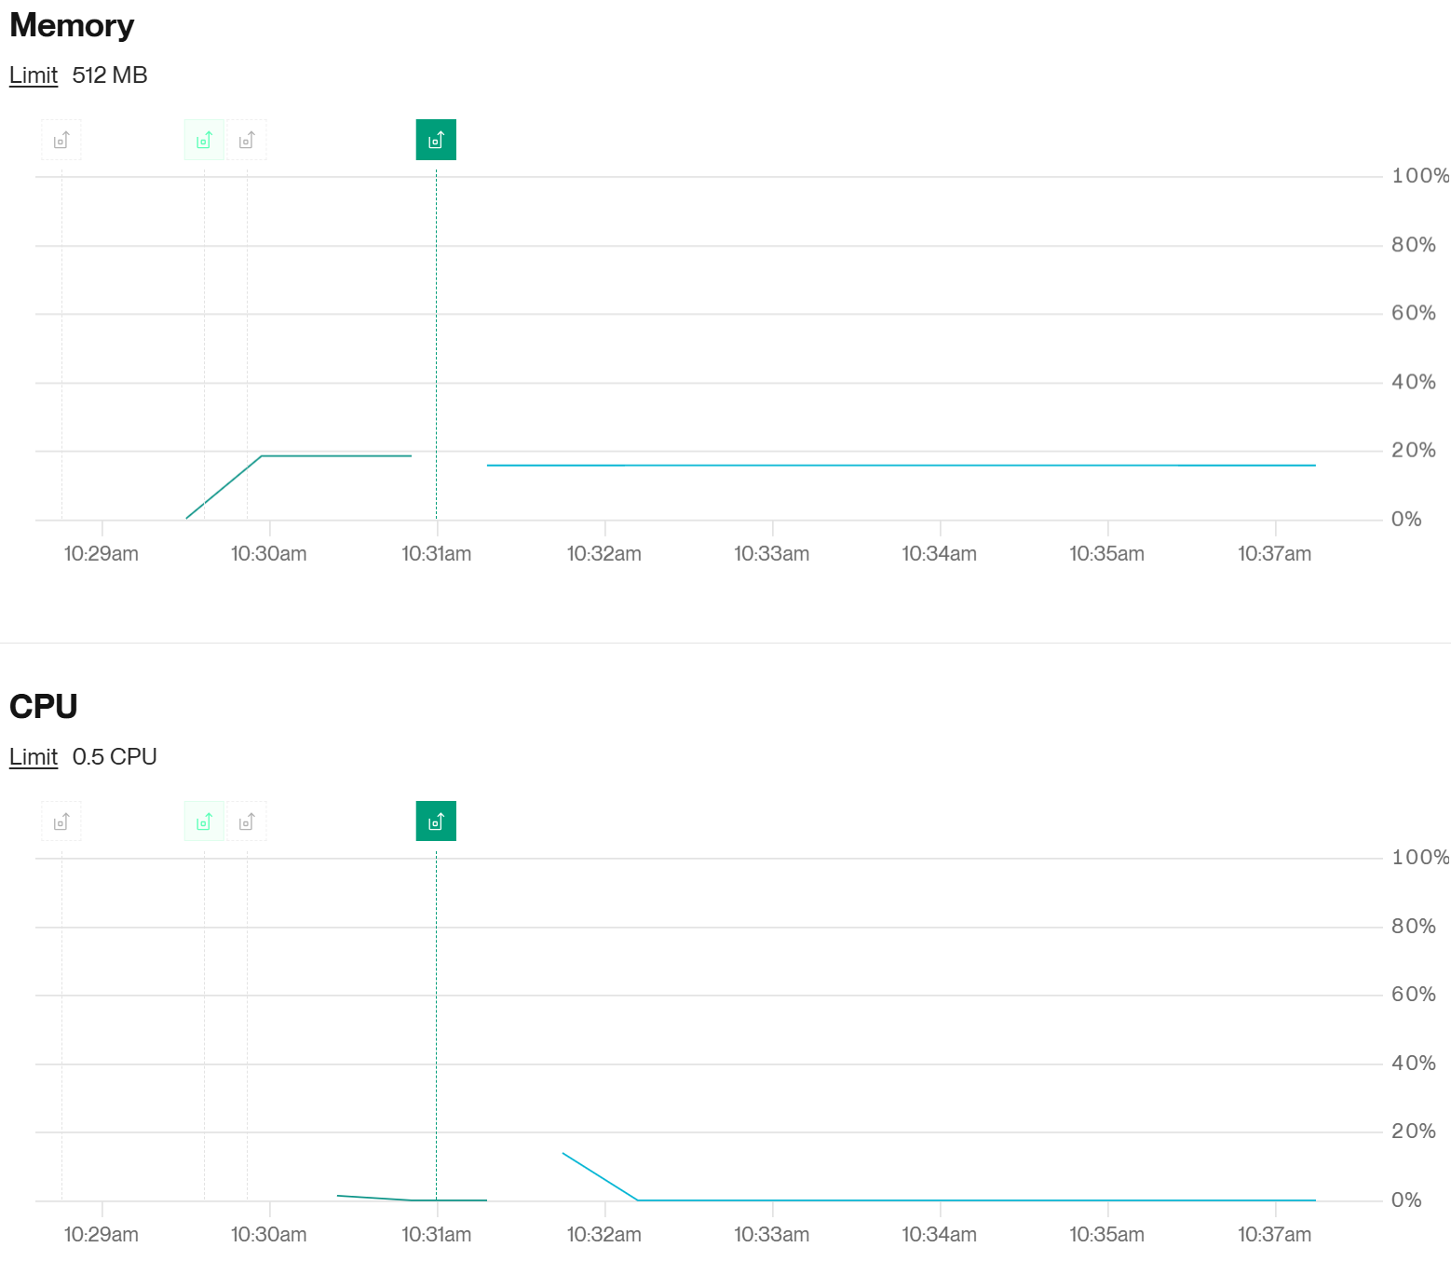
During / just after the write curl | 10:41 AM | Not Different | 2% | 18% | 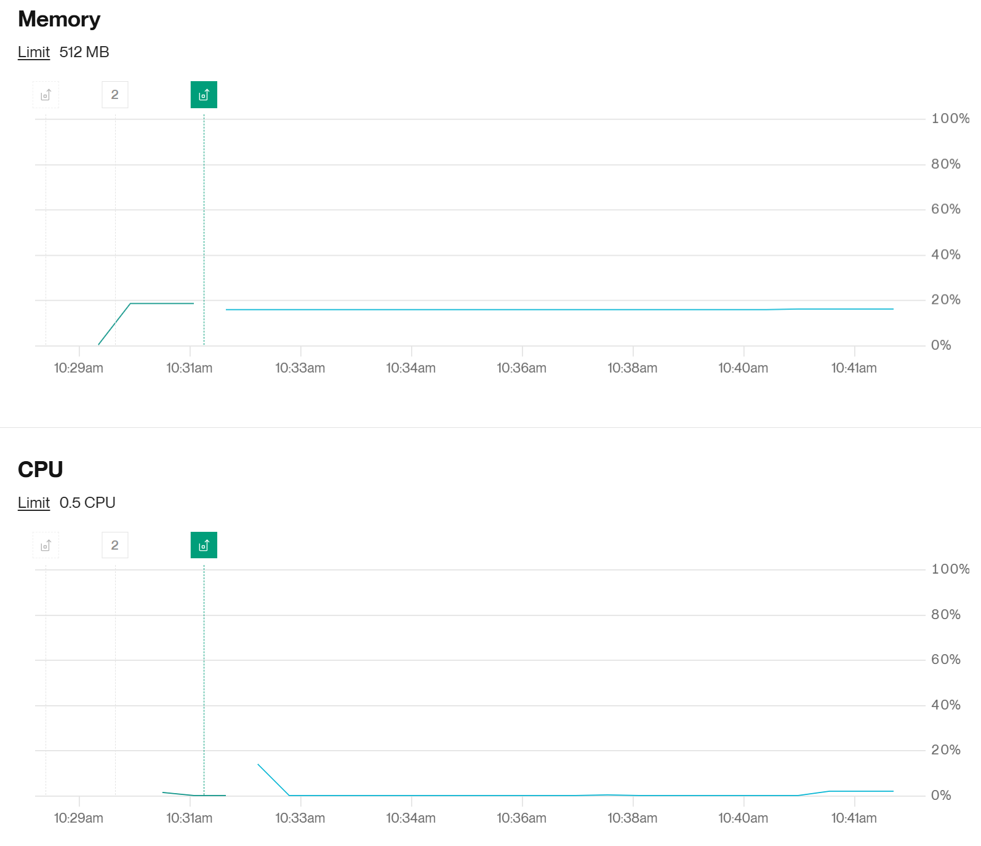

Local
When | Laptop Clock | Tool (Task Manager / Activity Monitor / top / docker stats) | Process or container name | CPU (approx. %) | Memory | Screenshot File
Idle | 11:03 AM | Task Manager | python.exe | 0% | 6,792 K
During the localhost read or write curl | 10:48 AM | Task Manager | python.exe | 0% | 32,840 K
~30 s after | 11:18 AM  (I ran another curl 30 sec prior) | Task Manager | python.exe | 0% | 24,080 K

Process name you watched: python.exe
I think I recorded the correct thing since it changed when I curled, I can’t really tell tho, never done this before

Supabase
When | Laptop Clock | Dashboard TZ (if different) | CPU (approx. %) | Memory | Screenshot File
Idle (no curls for a minute) | 11:28 AM | Not Different | 2% | 431.93 MB | 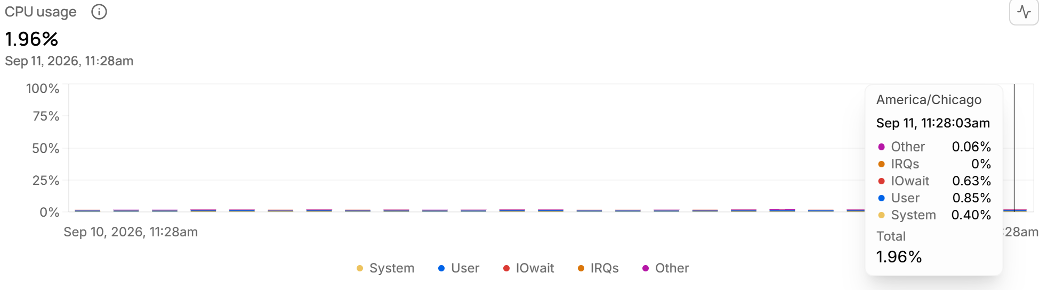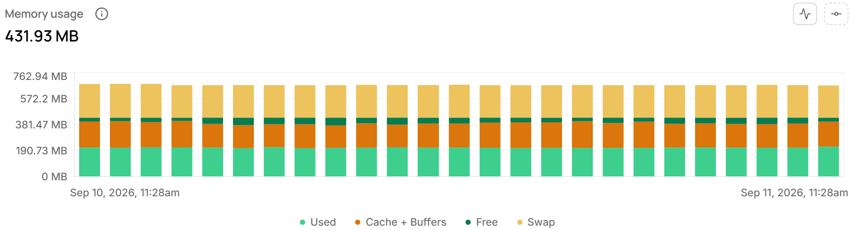
During / just after the write curl | 11:33 AM | Not Different | 15% | 413.93 MB | 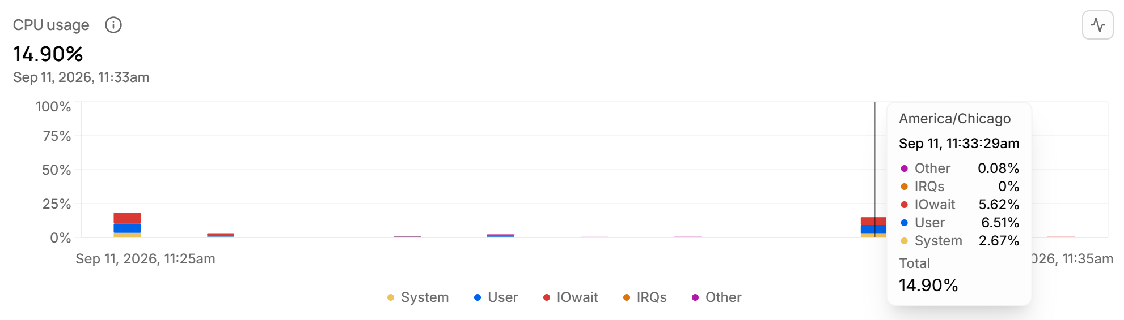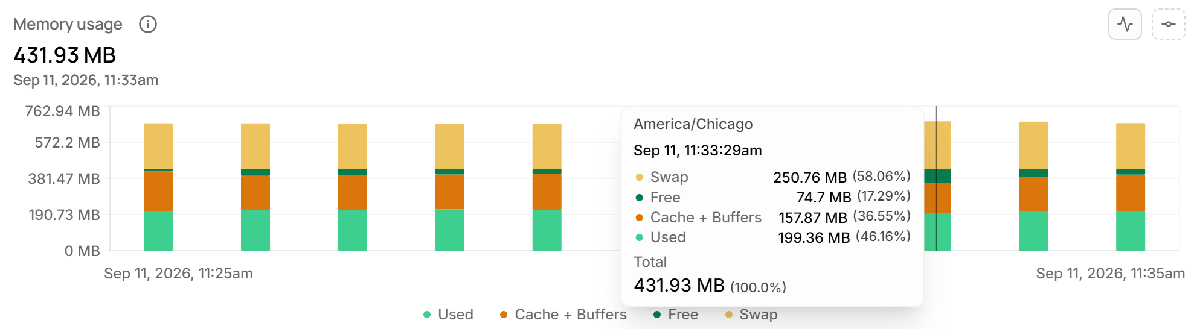
How many connections are open? 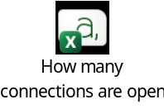
Who is connected, and what are they running? 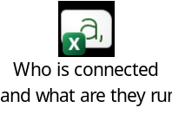
Environment H BASE: https://prin-of-software-methodology-project-m.onrender.com
Control: curl -sS https://prin-of-software-methodology-project-m.onrender.com/health auth? no
Read: curl -sS "https://prin-of-software-methodology-project-m.onrender.com/api/messages" \
-H "Authorization: Bearer <access-token-here>" auth? no
Write: curl -sS -X POST "https://prin-of-software-methodology-project-m.onrender.com/api/messages" \
-H "Content-Type: application/json" \
-H "Authorization: Bearer <access-token-here>" \
-d '{"body":"hello from curl"}' JSON body: hello from curl
How we export the token (paste the command, not the token):
export API_TOKEN="your_token_here"
curl -w variables we will use for cold start and payload:
time_total, size_download, http_code
Idle pg_stat_activity count: 6
Hosted API CPU: Render (or host) path we clicked: Render
Local API CPU: tool + how we opened it: Go to task manager, then details, then search Python.exe
Process we watched locally (name): python.exe
Windows users: curl.exe not needed

To find the payload / size of download (bytes): $ curl -sS "https://prin-of-software-methodology-project-m.onrender.com/api/messages" -H "Authorization: Bearer <access-token-here>" -w "%{size_download}" -o NUL
Actual Payload: 19795

python load_baseline.py --label 'Hosted Run 1-Concurrent Read Path' --concurrency 1 --base $BASE --path api/messages --method GET --token $M2_TOKEN --duration 60 --write-path api/messages --write-body {"body":"hello from curl {n}"}
python load_baseline.py --label 'Local Run 32-Concurrent Write Path' --concurrency 32 --base $LOCALBASE --path api/messages --mix 1 --method GET --token $M2_LOCALTOKEN --duration 60 --write-path api/messages --write-body {"body":"hello from curl {n}"}

